For: Students entering
3rd-8th grade
Cost: $150 per student includes:
- writing supplies
- daily snack
- copy of final publication

Scholarships Available
For information or application:
oxbowwp.weebly.com
(Youth Writing page)
or email director at:
kalseth23@gmail.com

July 13-23

  - Now Accepting Applications
Space is Limited– Deadline June 15, 2015

Improve your writing! Share your creativity!

Become a published author!

Join us for an exciting two weeks of writing!

Oxbow Youth Writing Project
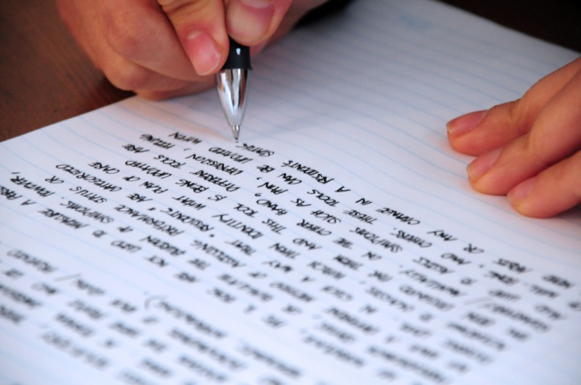

You are a writer.

I am a writer.

Monday – Thursday 9am – Noon

UNO – Roskens Hall

Oxbow Youth Writing Project Application
The Oxbow Youth Writing Project is a two week writing workshop for 3rd – 8th grade students.
The project will be held July 13 – 23, 2015 in Roskens Hall on the UNO Campus.
Name: _________________________________________ Grade Level (entering 2015/16) ____
School Attended for 2014/15 ______________________________________________________
Please tell us why you would like to be part of The Oxbow Writing Project: _________________
_____________________________________________________________________________
_____________________________________________________________________________
_____________________________________________________________________________
_____________________________________________________________________________
I agree to attend all eight days of the project. I agree to be positive and respectful, share my creativity, and be open to trying new ways of writing.
Student Signature: _________________________________________ Date: _______________

Parent/Guardian Contact: ________________________________________________________
Address: ______________________________________________________________________________
Telephone Number _____________________________ Email: _________________________________

___ Please send scholarship information/application via email
Parent/Guardian Signature: ______________________________________ Date ____________
Media Release
I give permission for photos to be taken of my student. These photos may be posted online on the Oxbow Writing Project website.
(please initial) Yes, I give permission_________ No, I decline permission_________
I give permission for my student’s name to be posted along with their picture. (please initial) Yes, I give permission_________ No, I decline permission_________
Please send completed applications to
Oxbow Youth Writing Project
Roskens Hall, 308
University of Nebraska at Omaha
or
kalseth23@gmail.com

